# Difference between old and new data sets

Old & new data set haves dates till 27/9/2018

For same customer:1015193

New data: train

mean 91.482684

std 170.405114

min -156.842600

25% 0.000000

50% 0.000000

75% 113.278646

max 813.317904

old data:train

mean -3438.513077

std 4674.396262

min -24863.169200

25% -5287.090673

50% -1821.800782

75% 0.000000

max 0.000000

New data model:

Train Score: 0.18 MSE (0.42 RMSE)

Test Score: 0.20 MSE (0.45 RMSE)

unscaled test score 427.618149 MSE

**MSE values decreases a lot for each epoch for new data compared to old one**

Old data model:

Train Score: 0.26 MSE (0.51 RMSE)

Test Score: 0.24 MSE (0.49 RMSE)

unscaled test score -9397.540099 MSE

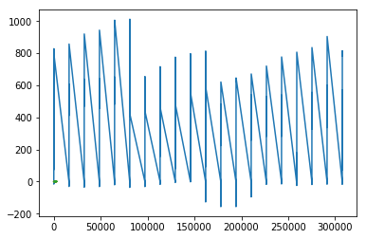 new data

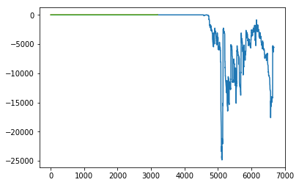 old data fro same customer

Predictions:

New data

New data on test data

Old data: